|  |  |  |  |  |
| --- | --- | --- | --- | --- |
| |  |  | | --- | --- | | Pluto’s Mad |  | |  |  | |
| ***COMP3064 – Game Programming***  ***Assignment 1***  ***Justin Frasca***  ***101020604*** |
|  |

# **Table of Contents**

**Page 1**

**Game Description**

**Controls Description**

**Page 2**

**Interface Sketch**

**Page 3**

**Screen Description**

**Page 4**

**Enemy’s**

**Scoring**

**Sound Index**

**Page 5**

**Art Index**

# **Game Description**

**“Pluto is mad that earth is saying it’s not a planet anymore!”**

**“Earth sent one hero to defend the galaxy and shoot down incoming spaceships!”**

The enemy isn’t technologically advanced enough to fire back so the hero is just having target practice but if the enemy gets past him he loses a life or if they crash into him he will also die so he has to be quicker and shoot as fast as he can to defend the earth.

# **Controls Description**

The Hero can go up down and forward and back using the arrow keys as well as (W, S, A, D);

The more he goes forward the harder the fight will be so he must keep his cool and stay close to home and utilize his shooting ability’s.

# **Interface Sketch**

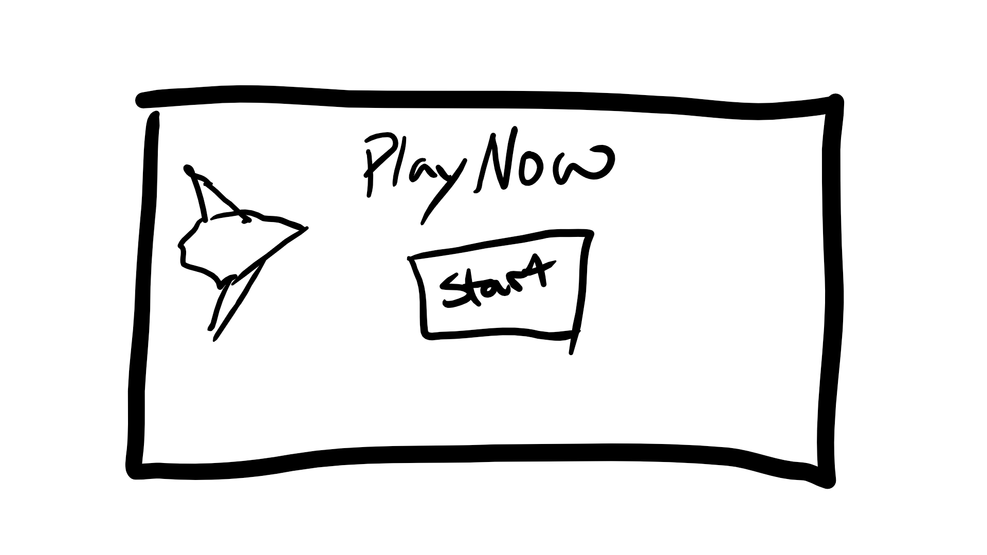

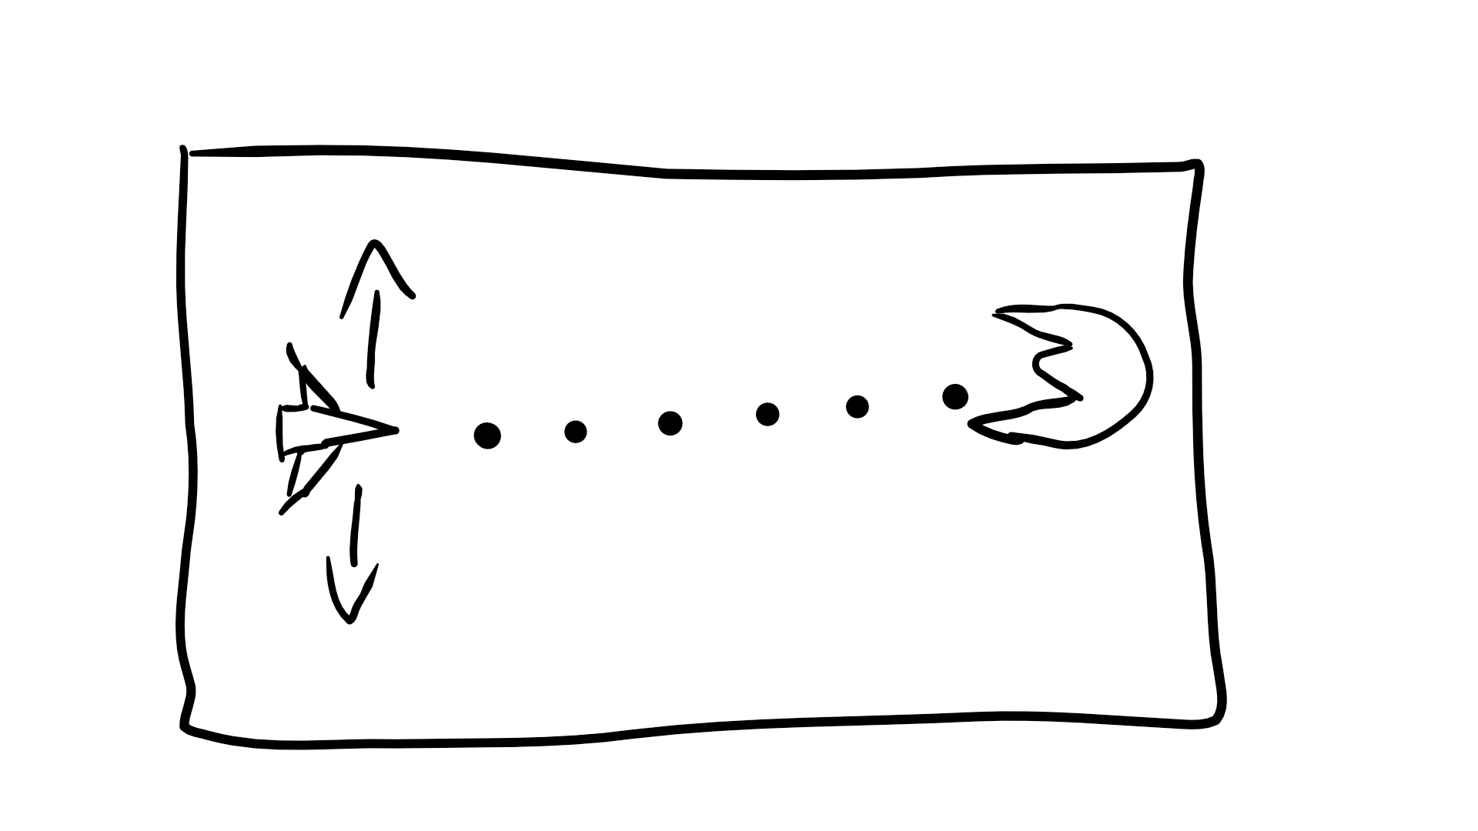

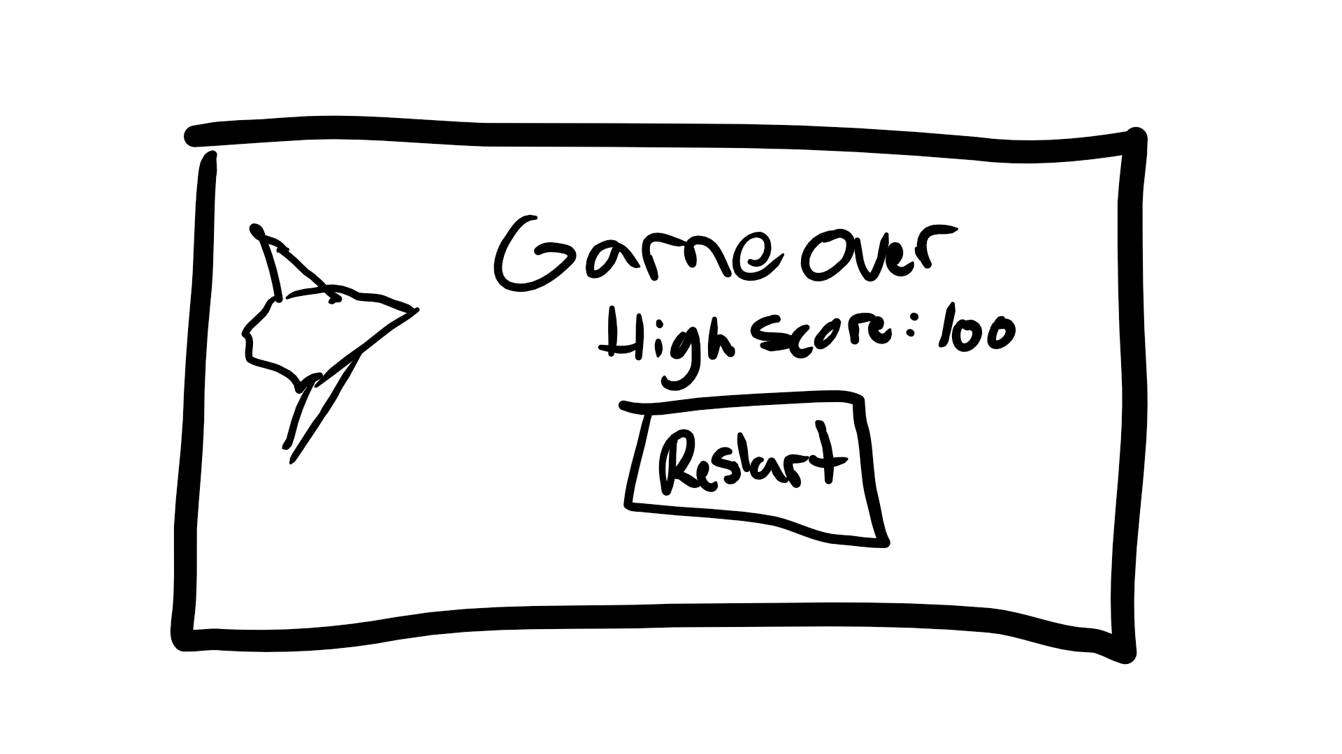

# **Screen Descriptions**

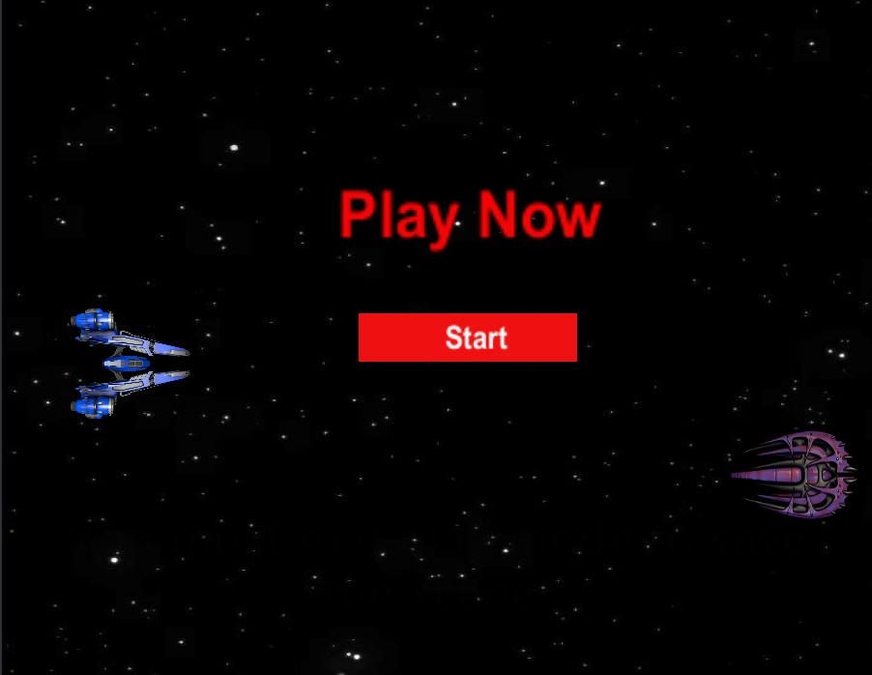

**Start Game**

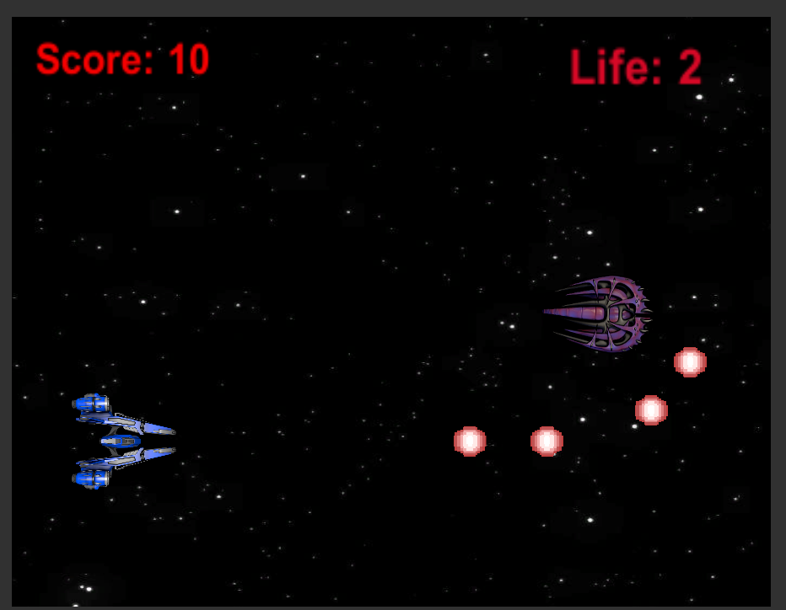

**Playing Game**

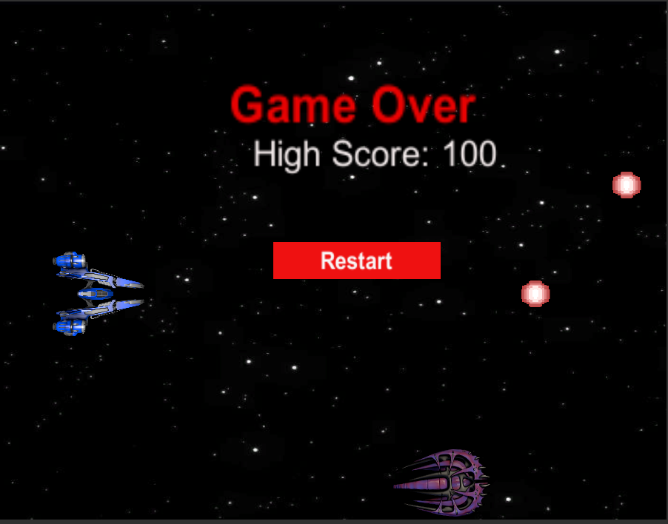

**Game over your high score and restart option**

# **Enemy’s**

**“They keep coming”**

The enemy’s spawn and go straight along the x axis. When the enemy respawns, they respawn anywhere on the screen at different speeds. They can destroy the player if they get past the player or crash into him.

# **Scoring**

The Player can score based on shooting down the opponents. Every time the player shoots one enemy down the score goes up by 10 points.

# **Sound Index**

**Exploding when opponents hit**



**Shooting sounds**



**Background noise (can’t index it)**

# **Art Index**

**[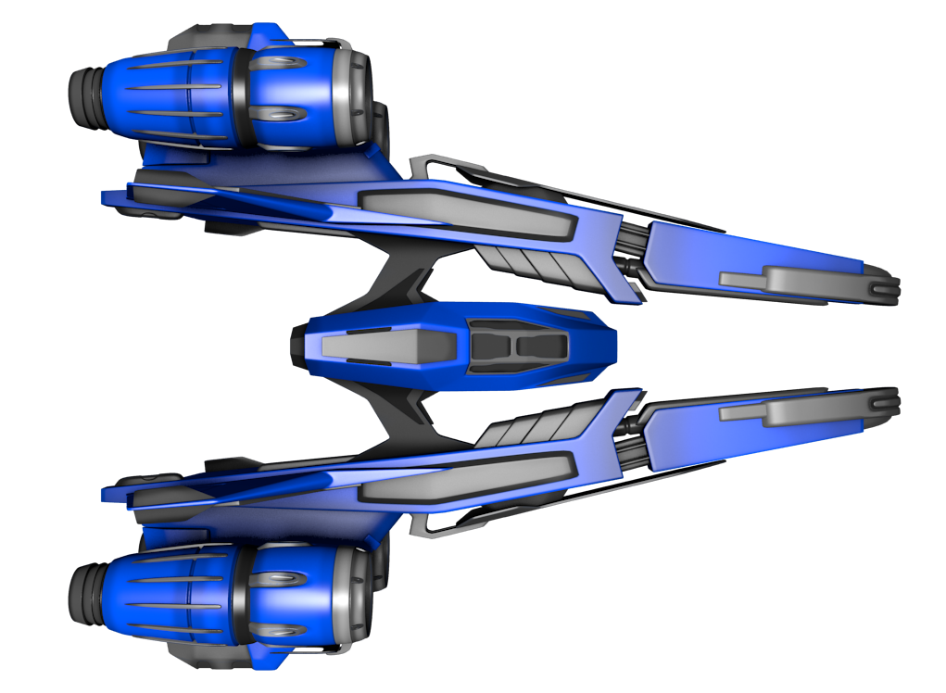](https://www.google.ca/url?sa=i&rct=j&q=&esrc=s&source=images&cd=&cad=rja&uact=8&ved=0ahUKEwiN8_a_h_zWAhVi64MKHZQpBQEQjRwIBw&url=https%3A%2F%2Fwww.pinterest.com%2Fpin%2F453315518732356746%2F&psig=AOvVaw01Uyi1PRPq_s16HUpeZ-DW&ust=1508480917165952)**

**Space Ship Main**

**[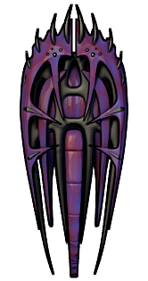](https://www.google.ca/url?sa=i&rct=j&q=&esrc=s&source=images&cd=&cad=rja&uact=8&ved=0ahUKEwjDhv_0h_zWAhVr34MKHWJ_Dp0QjRwIBw&url=http%3A%2F%2Fmillionthvector.blogspot.com%2Fp%2Ffree-sprites.html&psig=AOvVaw01Uyi1PRPq_s16HUpeZ-DW&ust=150848091716595)**

**Enemy Spaceship**

**[](https://www.google.ca/url?sa=i&rct=j&q=&esrc=s&source=images&cd=&cad=rja&uact=8&ved=0ahUKEwjP9IGRifzWAhVswYMKHRy_AZgQjRwIBw&url=https%3A%2F%2Fwww.youtube.com%2Fwatch%3Fv%3DM2uBtg_PzKg&psig=AOvVaw2WvLlywMZCJSqAHbuYMNlL&ust=1508481361001783)**

**Space Background**